**GROUP 8:**

**BAGADIONG**

**FAJARDO**

**MACHINE PROBLEM #2 (MATLAB SOLUTION)**

**Test #1 and Test #2:**

Input values for test #1: -3, 5, 3, 3, 11, 19

Input values for test #2: -3, 5, 3, 3, 11, 19

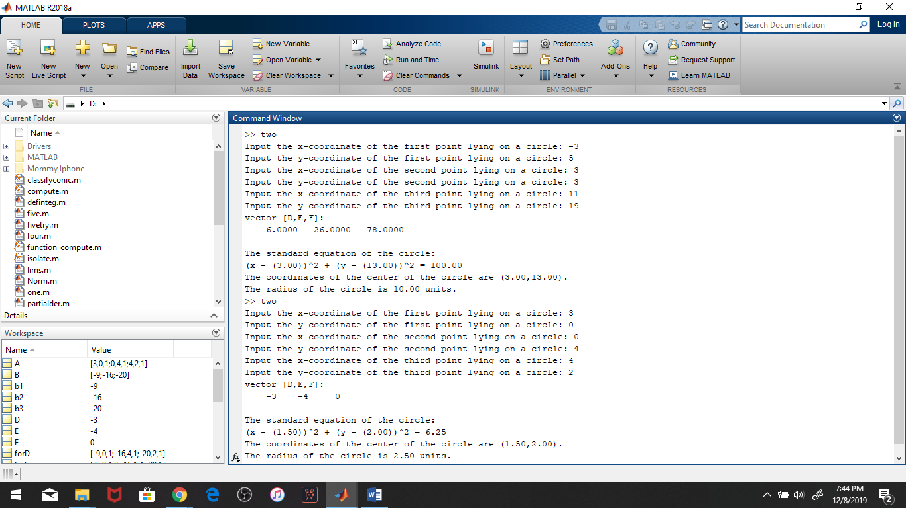

**Script file:**

